SEC Form 4
FORM 4 |  | UNITED STATES SECURITIES AND EXCHANGE COMMISSION  Washington, D.C. 20549  STATEMENT OF CHANGES IN BENEFICIAL OWNERSHIP  Filed pursuant to Section 16(a) of the Securities Exchange Act of 1934  or Section 30(h) of the Investment Company Act of 1940
  OMB APPROVAL
  OMB Number: | 3235-0287
  Estimated average burden
  hours per response: | 0.5
 | Check this box if no longer subject to Section 16. Form 4 or Form 5 obligations may continue. See Instruction 1(b).
 | Check this box to indicate that a transaction was made pursuant to a contract, instruction or written plan for the purchase or sale of equity securities of the issuer that is intended to satisfy the affirmative defense conditions of Rule 10b5-1(c). See Instruction 10.
1. Name and Address of Reporting Person*  (Street) | 2. Issuer Name and Ticker or Trading Symbol  MARRIOTT VACATIONS WORLDWIDE Corp [ VAC ]  Foreign Trading Symbol | 5. Relationship of Reporting Person(s) to Issuer  (Check all applicable)
  Anokhin Vladimir
  (Last) | (First) | (Middle)
  7812 PALM PKWY
  ORLANDO | FL | 32836
  (City) | (State) | (Zip)
   | Director |  | 10% Owner
   | Officer (give title below) |  | Other (specify below)
  See Remarks
3. Date of Earliest Transaction (Month/Day/Year)
08/17/2026
 | 4. If Amendment, Date of Original Filed (Month/Day/Year) | 6. Individual or Joint/Group Filing (Check Applicable Line)
  Form filed by One Reporting Person
  Form filed by More than One Reporting Person
Table I - Non-Derivative Securities Acquired, Disposed of, or Beneficially Owned
1. Title of Security (Instr. 3) | 2. Transaction Date (Month/Day/Year) | 2A. Deemed Execution Date, if any (Month/Day/Year) | 3. Transaction Code (Instr. 8) |  | 4. Securities Acquired (A) or Disposed Of (D) (Instr. 3, 4 and 5) |  |  | 5. Amount of Securities Beneficially Owned Following Reported Transaction(s) (Instr. 3 and 4) | 6. Ownership Form: Direct (D) or Indirect (I) (Instr. 4) | 7. Nature of Indirect Beneficial Ownership (Instr. 4)
1. Title of Security (Instr. 3) | 2. Transaction Date (Month/Day/Year) | 2A. Deemed Execution Date, if any (Month/Day/Year) | Code | V | Amount | (A) or (D) | Price |  | 6. Ownership Form: Direct (D) or Indirect (I) (Instr. 4) | 7. Nature of Indirect Beneficial Ownership (Instr. 4)
Table II - Derivative Securities Acquired, Disposed of, or Beneficially Owned
(e.g., puts, calls, warrants, options, convertible securities)
1. Title of Derivative Security (Instr. 3) | 2. Conversion or Exercise Price of Derivative Security | 3. Transaction Date (Month/Day/Year) | 3A. Deemed Execution Date, if any (Month/Day/Year) | 4. Transaction Code (Instr. 8) |  | 5. Number of Derivative Securities Acquired (A) or Disposed of (D) (Instr. 3, 4 and 5) |  | 6. Date Exercisable and Expiration Date (Month/Day/Year) |  | 7. Title and Amount of Securities Underlying Derivative Security (Instr. 3 and 4) |  | 8. Price of Derivative Security (Instr. 5) | 9. Number of derivative Securities Beneficially Owned Following Reported Transaction(s) (Instr. 4) | 10. Ownership Form: Direct (D) or Indirect (I) (Instr. 4) | 11. Nature of Indirect Beneficial Ownership (Instr. 4)
 |  |  |  | Code | V | (A) | (D) | Date Exercisable | Expiration Date | Title | Amount or Number of Shares
Performance Stock Unit | (1) | 08/17/2026 |  | A |  | 1,250(1) |  | (1) | (1) | Common Stock | 2,500(1) | $0 | 1,250(1) | D
Explanation of Responses:
1. Represents restricted stock units granted at a target level and vests on December 31, 2028, or June 30, 2029, as applicable, and to be distributed following the Issuer's certification of performance. The actual number of shares of common stock that may be earned will range from 0% to 200% of the target number based on the achievement of specified stock price performance goals over the applicable performance period.
Remarks:
Title: Chief Strategy and Transformation Officer
 | /s/ Harold Herman, Attorney-In-Fact | 08/18/2026
 | ** Signature of Reporting Person | Date
Reminder: Report on a separate line for each class of securities beneficially owned directly or indirectly.
* If the form is filed by more than one reporting person, see Instruction 4 (b)(v).
** Intentional misstatements or omissions of facts constitute Federal Criminal Violations See 18 U.S.C. 1001 and 15 U.S.C. 78ff(a).
Note: File three copies of this Form, one of which must be manually signed. If space is insufficient, see Instruction 6 for procedure.
Persons who respond to the collection of information contained in this form are not required to respond unless the form displays a currently valid OMB Number.
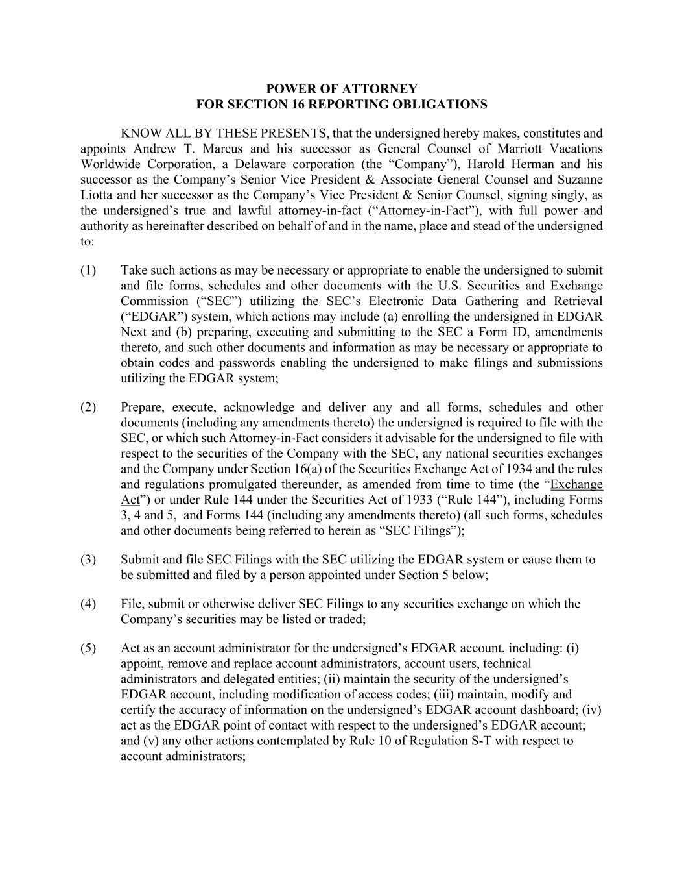
POWER OF ATTORNEY FOR SECTION 16 REPORTING OBLIGATIONS KNOW ALL BY THESE PRESENTS, that the undersigned hereby makes, constitutes and appoints Andrew T. Marcus and his successor as General Counsel of Marriott Vacations Worldwide Corporation, a Delaware corporation (the “Company”), Harold Herman and his successor as the Company’s Senior Vice President & Associate General Counsel and Suzanne Liotta and her successor as the Company’s Vice President & Senior Counsel, signing singly, as the undersigned’s true and lawful attorney-in-fact (“Attorney-in-Fact”), with full power and authority as hereinafter described on behalf of and in the name, place and stead of the undersigned to: (1) Take such actions as may be necessary or appropriate to enable the undersigned to submit and file forms, schedules and other documents with the U.S. Securities and Exchange Commission (“SEC”) utilizing the SEC’s Electronic Data Gathering and Retrieval (“EDGAR”) system, which actions may include (a) enrolling the undersigned in EDGAR Next and (b) preparing, executing and submitting to the SEC a Form ID, amendments thereto, and such other documents and information as may be necessary or appropriate to obtain codes and passwords enabling the undersigned to make filings and submissions utilizing the EDGAR system; (2) Prepare, execute, acknowledge and deliver any and all forms, schedules and other documents (including any amendments thereto) the undersigned is required to file with the SEC, or which such Attorney-in-Fact considers it advisable for the undersigned to file with respect to the securities of the Company with the SEC, any national securities exchanges and the Company under Section 16(a) of the Securities Exchange Act of 1934 and the rules and regulations promulgated thereunder, as amended from time to time (the “Exchange Act”) or under Rule 144 under the Securities Act of 1933 (“Rule 144”), including Forms 3, 4 and 5, and Forms 144 (including any amendments thereto) (all such forms, schedules and other documents being referred to herein as “SEC Filings”); (3) Submit and file SEC Filings with the SEC utilizing the EDGAR system or cause them to be submitted and filed by a person appointed under Section 5 below; (4) File, submit or otherwise deliver SEC Filings to any securities exchange on which the Company’s securities may be listed or traded; (5) Act as an account administrator for the undersigned’s EDGAR account, including: (i) appoint, remove and replace account administrators, account users, technical administrators and delegated entities; (ii) maintain the security of the undersigned’s EDGAR account, including modification of access codes; (iii) maintain, modify and certify the accuracy of information on the undersigned’s EDGAR account dashboard; (iv) act as the EDGAR point of contact with respect to the undersigned’s EDGAR account; and (v) any other actions contemplated by Rule 10 of Regulation S-T with respect to account administrators;

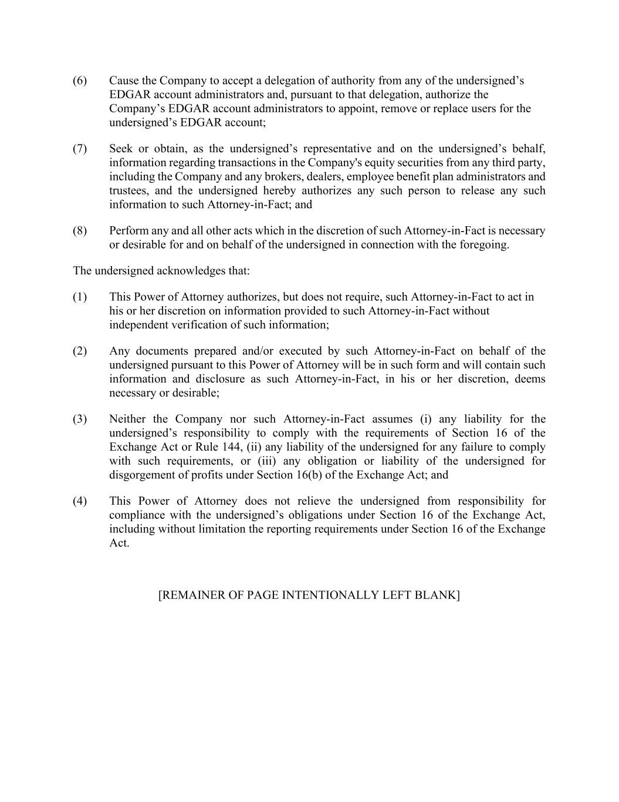
(6) Cause the Company to accept a delegation of authority from any of the undersigned’s EDGAR account administrators and, pursuant to that delegation, authorize the Company’s EDGAR account administrators to appoint, remove or replace users for the undersigned’s EDGAR account; (7) Seek or obtain, as the undersigned’s representative and on the undersigned’s behalf, information regarding transactions in the Company's equity securities from any third party, including the Company and any brokers, dealers, employee benefit plan administrators and trustees, and the undersigned hereby authorizes any such person to release any such information to such Attorney-in-Fact; and (8) Perform any and all other acts which in the discretion of such Attorney-in-Fact is necessary or desirable for and on behalf of the undersigned in connection with the foregoing. The undersigned acknowledges that: (1) This Power of Attorney authorizes, but does not require, such Attorney-in-Fact to act in his or her discretion on information provided to such Attorney-in-Fact without independent verification of such information; (2) Any documents prepared and/or executed by such Attorney-in-Fact on behalf of the undersigned pursuant to this Power of Attorney will be in such form and will contain such information and disclosure as such Attorney-in-Fact, in his or her discretion, deems necessary or desirable; (3) Neither the Company nor such Attorney-in-Fact assumes (i) any liability for the undersigned’s responsibility to comply with the requirements of Section 16 of the Exchange Act or Rule 144, (ii) any liability of the undersigned for any failure to comply with such requirements, or (iii) any obligation or liability of the undersigned for disgorgement of profits under Section 16(b) of the Exchange Act; and (4) This Power of Attorney does not relieve the undersigned from responsibility for compliance with the undersigned’s obligations under Section 16 of the Exchange Act, including without limitation the reporting requirements under Section 16 of the Exchange Act. [REMAINER OF PAGE INTENTIONALLY LEFT BLANK]

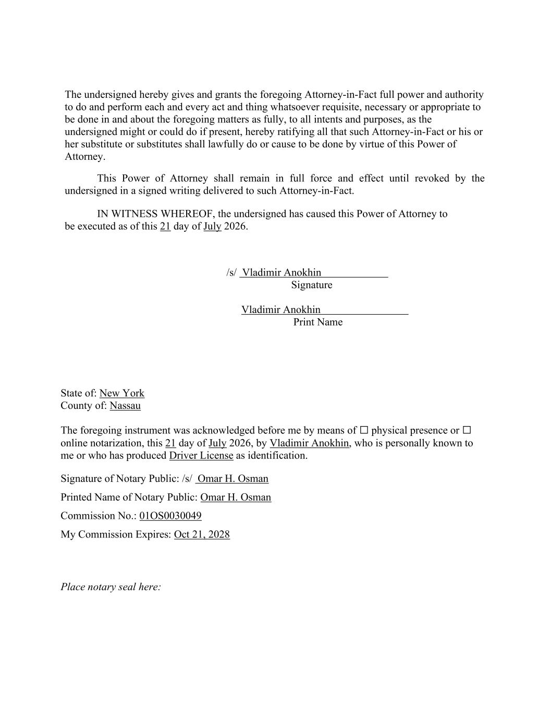
The undersigned hereby gives and grants the foregoing Attorney-in-Fact full power and authority to do and perform each and every act and thing whatsoever requisite, necessary or appropriate to be done in and about the foregoing matters as fully, to all intents and purposes, as the undersigned might or could do if present, hereby ratifying all that such Attorney-in-Fact or his or her substitute or substitutes shall lawfully do or cause to be done by virtue of this Power of Attorney. This Power of Attorney shall remain in full force and effect until revoked by the undersigned in a signed writing delivered to such Attorney-in-Fact. IN WITNESS WHEREOF, the undersigned has caused this Power of Attorney to be executed as of this 21 day of July 2026. /s/ Vladimir Anokhin Signature Vladimir Anokhin Print Name State of: New York County of: Nassau The foregoing instrument was acknowledged before me by means of ☐ physical presence or ☐ online notarization, this 21 day of July 2026, by Vladimir Anokhin, who is personally known to me or who has produced Driver License as identification. Signature of Notary Public: /s/ Omar H. Osman Printed Name of Notary Public: Omar H. Osman Commission No.: 01OS0030049 My Commission Expires: Oct 21, 2028 Place notary seal here:

